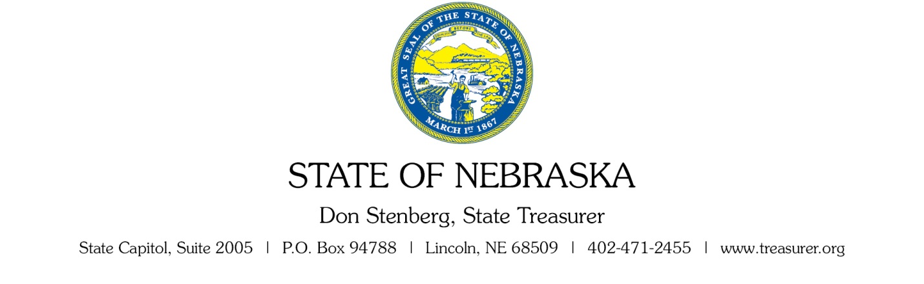

ADDENDUM TWO, QUESTIONS and ANSWERS

Date: 09/27/2017

To: All Bidders

From: Jason Walters, Buyer
Nebraska State Treasurer’s Office

RE: Addendum Request for Proposal Number NST082017Z1
to be opened October 20, 2017 at 2:00 PM Central Time.

No additional questions were received.

This addendum will become part of the proposal and should be acknowledged with the Request for Proposal.

